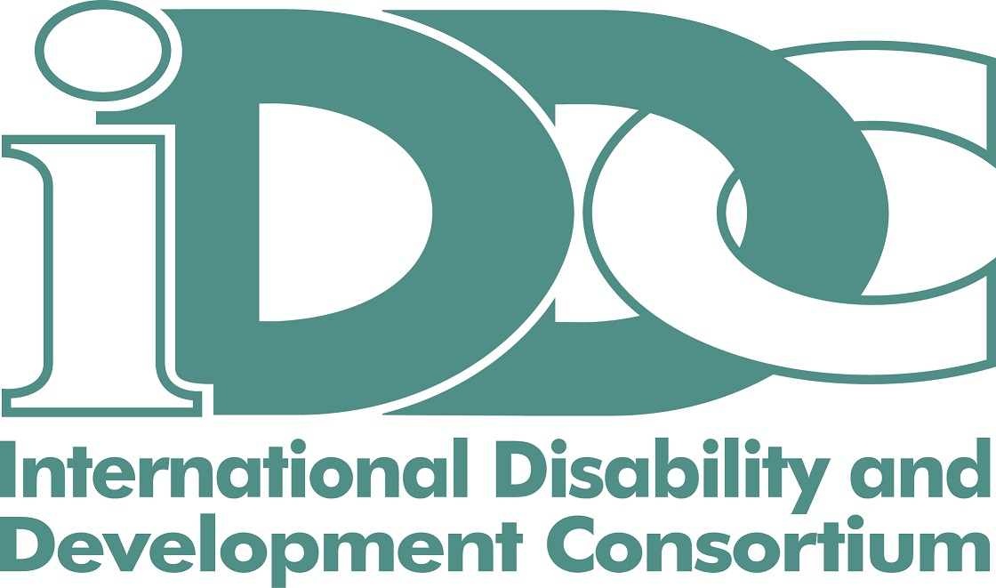
European Disability and Development Week 2018

Together for Inclusion | Leave No One Behind
December 3-10, 2018

For the 3rd time, IDDC will organise the European Disability and Development Week, starting with the International Day of Persons with Disabilities (December 3rd) and concluding a week later on Human Rights Day (December 10th).

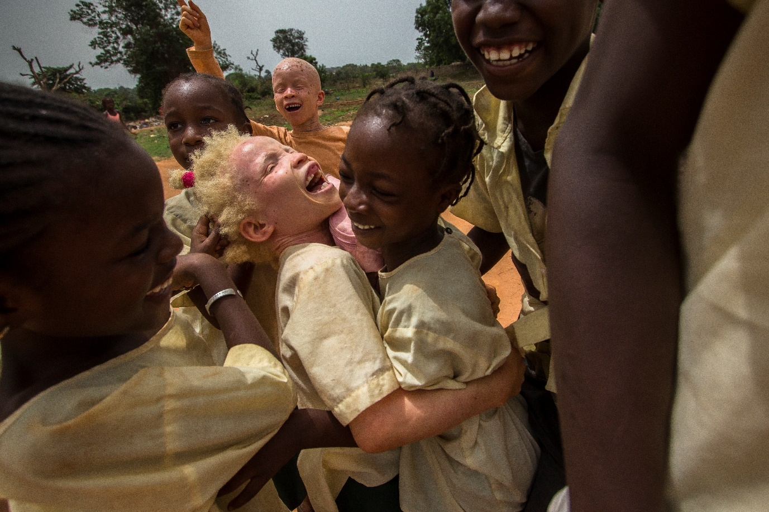
#EDDW18 has 3 objectives

- Showcase the breadth and variety of disability inclusion in international development

- Encourage solidarity and participation across Europe for disability inclusion

- Strengthen interaction between decision makers and representatives of persons with disabilities.
  - ‘Aicha and Friends’, taken by Marta Moreiras, winner of the #EDDW17 photo competition

For the week to be a success we need your participation!

Very simple! If you are planning to organise any event (e.g. conference, publication launch, campaign, film, party or project presentation) anywhere in Europe between December 3 and 10, in line with our theme “Together for Inclusion, Leave No One Behind”, then you could link it to #EDDW18.
In return, you’ll get a broader visibility and audience, as we’ll all commit to supporting each other.

Few practical details:
- Events can be organised by IDDC members and any other organisations partnering with an IDDC member.
- All organisers are required to register their event online.
- A photo competition is being organized.
- IDDC does not provide any funding to organise events.

Check details on: https://iddcconsortium.net/what-we-do/european-union/european-disability-development-week-2018

For any information, please contact: b.bouniol@hi.org

